 

***Session 4***

***4-09-2022***

***---------------------------------------------------------***

***Tasks***

1-why apple’s processors is better ?

**Apple Silicon chips are RISC chips, while Intel chips are CISC chips. The comparison is not Apple vs Intel, but RISC vs CISC. “RISC” is “reduced instruction set computing,” and “CISC” is “complex instruction computing.”**

**CISC chips, such as Intel and AMD, have a large number of instructions, of varying length, and some are rarely used. The CISC chip has the overhead of determining whether it has the entire instruction. CISC chips acquire cruft over the years, which slows them down. Since the instruction set is complicated, the chip is more complex and therefore slower in comparison to an equally powerful RISC chip.**

**RISC chips, such as Apple Silicon and ARM, have fewer instructions, and all of them have the same length, so there is no overhead in determining whether the chip has the entire instruction. Since the instruction set is simple, the chip is simpler and therefore faster.**

**RISC chips power the fastest supercomputer in the world, which is in Japan**.

2-the difference between processors in performance and all features?

[CPU comparison & rankings | Compare processors - Versus](https://versus.com/en/cpu)

**Clock Speed Isn't Everything**

**Clock speed and cores are the most heavily advertised aspects of processors. Clock speed is usually noted in hertz (e.g., 3.14GHz), while the number of cores is usually advertised as dual-core, quad-core, hexa-core, or octa-core.**

**Are you curious about what makes a CPU better than another and how to compare CPUs accurately?**

**For a long time, it was this simple: the higher the clock speed, the faster the processor, and more cores meant better speeds. But processor technology today isn't dependent as much on clock speeds and cores because CPUs now have several other parts that determine how fast they can perform.**

**In a nutshell, it comes down to how much computing can be done when all parts of a CPU come together in a single clock cycle. If performing Task X takes two clock cycles on CPU A and one clock cycle on CPU B, then CPU B might be the better processor even if CPU A has a higher clock speed.**

**Overall, you can't just rely on clock speed or cores, which are the two most heavily advertised aspects of processors. You should compare clock speeds only when you are trying to decide between two CPUs from the same family and the same number of cores. What this means is that if you're looking at two quad-core Intel Core i5 Skylake processors, then the one with the higher clock speed will be faster**

**Check Single-Threaded Performance**

**The dirty little secret in the computer world is that even though you're buying a processor with four cores, all four of those cores might not be used when you're running applications.**

**Most software today is still single-threaded, which means the program is running as one process, and a process can only run on one core. So even if you have four cores, you won't be getting the full performance of all four cores for that application.**

**That's why you also need to check the single-threaded (or single-core) performance of any processor before buying it. Not all companies explicitly release that information, so you'll need to rely on third-party data from reliable resources like Passmark.**

**Cache Performance Is King**

**The cache is one of the most under-appreciated parts of a CPU. In fact, a cache with poor specs could be slowing down your PC. So, you should always check the cache specs of a processor before you purchase it.**

**Cache is essentially RAM for your processor, which means that the processor uses the cache to store all of the functions it has recently performed. Whenever those functions are requested again, the processor can draw the data from the cache instead of performing them a second time, thus making it faster**.

* **Power consumbsion**

### 3-what’s the difference between tabulation and Memoization?

### Tabulation is a technique that is used to implement the DP algorithms. It is also known as a bottom-up approach. It starts from solving the lowest level sub-problem. The solution to the lowest level sub-problem will help to solve next level sub-problem, and so forth. We solve all the sub-problems iteratively until we solve all the sub-problems. This approach saves the time when a sub-problem needs a solution of the sub-problem that has been solved before.

### Memoization is a technique that is used to implement the DP algorithms. Memoization is also known as a top-down approach. It starts from solving the highest-level sub-problems. Initially, it solves the highest-level subproblem and then solve the next sub-problem recursively and the next. Suppose there are two sub-problems, i.e., sub-problem A and sub-problem B. When sub-problem B is called recursively, then it can use the solution of sub-problem A, which has already been used. Since A and all the sub-problems are memoized, it avoids solving the entire recursion tree generated by B and saves computation time.

1. **Tabulation:** Bottom Up
2. **Memoization:** Top Down

### Tabulation: Tabulation is a technique used for solving the sub-problem recursively. The below code shows the working of the tabulation:

In [18]:

**def** fib(n):

**if** n**<=**1:

**return** n;

**else**:

**return** fib(n**-**2) **+** fib(n**-**1)

Suppose we want to calculate the fibonacci sequence of f(5). The Fibonacci sequence of f(5) is 0, 1, 1, 2, 3, 5. There is a total 15 calls to be used to calculate f(15).

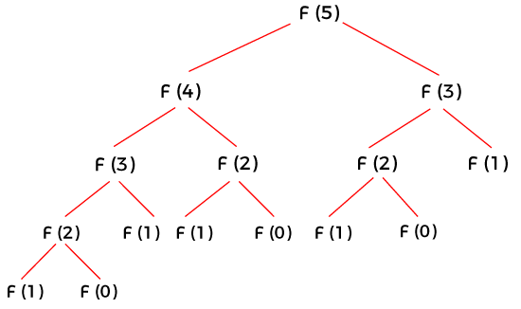

### Memoization: Memoization is a technique used for solving the sub-problem non-recursively.

In [21]:

**def** fib(n):

**if** n**<=**1:

**return** n;

f[0] **=** 0

f[1] **=** 1

**for** i **in** range(2,n):

f[i] **=** f[i**-**2] **+** f[i**-**1]

**return** f[n];

The above code takes a time complexity of O(2^n). This time complexity is non-linear. To reduce this time complexity, we can use the technique of memoization. This technique reduces the number of calls, and it reduces the time complexity.

4-what’s linear probing?

## What is a Collision?

A collision occurs in a hash table when our put method attempts to store multiple values at the same hash index.

## What is Linear Probling?

Linear probing is a specific application of open address hashing in which we search for an available index linearly.

5-watch Hash table Mostafa saad?

Done

6-what’s dynamic allocation and how do this?

* *Dynamic memory allocation is the process of assigning the memory space during the execution time or the run time*
* **All memory needs to define the variables needed before program execution , But there may be cases where the memory needs of a program can only be determined during runtime. For example, when the memory needed depends on user input.**
* **the C++ language integrates the operators new and delete to solve that**
* **In C, dynamic memory is allocated from the heap using some standard library functions. The two key dynamic memory functions are malloc() and free()**

7-All C++ frameworks in all tracks?

[fffaraz/awesome-cpp: A curated list of awesome C++ (or C) frameworks, libraries, resources, and shiny things. Inspired by awesome-... stuff. (github.com)](https://github.com/fffaraz/awesome-cpp#frameworks)

8-how can I write line and another line with different programming language?

**Integrate more than compiler to compile more than languages**

## Embedding

Generally, a single source file contains code for exactly one programming language. It is uncommon for multiple languages to be combined in a single file for a couple of reasons:

### Parsing several syntactically-different languages at once is extremely difficult (if not outright impossible).

### Different languages treat programming differently. Haskell's notion of a function is different than C++'s.

## Linking

Different programming languages that share a common application binary interface may be combined to form a single executable or library. Getting the two languages' signatures available inside each other often takes a bit of work, but tools exist to ease the process.

## Polyglots

Polyglot code is valid and equivalent in more than one language.

Example : <https://foojay.io/today/java-panama-polyglot-part1/>

9-what’s Cronjobs,examples?

**A cron job is used for scheduling tasks to be executed sometime in the future. This is normally used to schedule a job that is executed periodically**

**For most cron jobs, there are three components present:**

**1. The script that is to be called or executed.**

**2. The command that executes the script on a reoccurring basis. This is typically set in cPanel.**

**3. The action or output of the script, which depends on what the script being called does. Frequently, scripts called as cron jobs modify files or databases. However, they can perform other tasks that do not modify data on the server as well, such as sending out email notifications.**

[**https://www.hivelocity.net/kb/what-is-cron-job/**](https://www.hivelocity.net/kb/what-is-cron-job/)

**.**

10-what’s APi ? what’s web services and micro services?

**intermediate between database and users or user interface to get the data from**

**APIs let your product or service communicate with other products and services without having to know how they’re implemented**

**API stands for Application Programming Interface. In the context of APIs, the word Application refers to any software with a distinct function. Interface can be thought of as a contract of service between two applications. This contract defines how the two communicate with each other using requests and responses. Their API documentation contains information on how developers are to structure those requests and responses.**

* **Microservice:** A small, autonomous application that performs a specific service for a larger application architecture.
* **Web service:** A strategy to make the services of one application available to other applications via a web interface. Microservices, or microservices architecture, is an approach to application development in which a large application is built from modular components or services. Each module supports a specific task or business goal and uses a simple, well-defined interface, such as an application programming interface (API), to communicate with other sets of services.
* How microservices work
* In a microservices architecture, an application is divided into services. Each service runs a unique process and usually manages its own database. A service can generate alerts, log data, support user interfaces (UIs), handle user identification or authentication and perform various other tasks.
* The microservices paradigm provides development teams with a more decentralized approach to building software. Each service can be isolated, rebuilt, redeployed and managed independently. For example, if a program isn't properly generating reports, IT staff can trace the problem to a specific service and then test, restart, patch and redeploy that service as needed, independent of other services.

What is difference between microservices and web services?

* The differences between microservices and web services deal with different concepts in modern application design. A microservice is a small, independent, application that performs a highly focused service as well as possible. A web service is an internet-based interface that makes the “services” of one application available to applications running on different platforms.
* Since microservices are one of the most popular concepts in application development right now, they’re getting a lot more attention than web services. However, both concepts are highly relevant when building a modular, services-oriented application architecture – so it’s important to understand how both fit into the picture of modern app design.

11-compare between core i9 and i7 in the same task

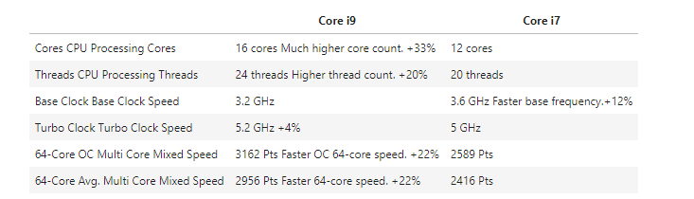

12-why set is faster data structure?

**Set is implemented by a hash-table data structure. For this reason, checking if a specific value exists in the set, is instant O(1) time, requires no iteration. On the other hand to check if a value is included in a list, all elements must be checked in a loop, so that is O(n) time.**